NEW CHECK-IN PROCESS
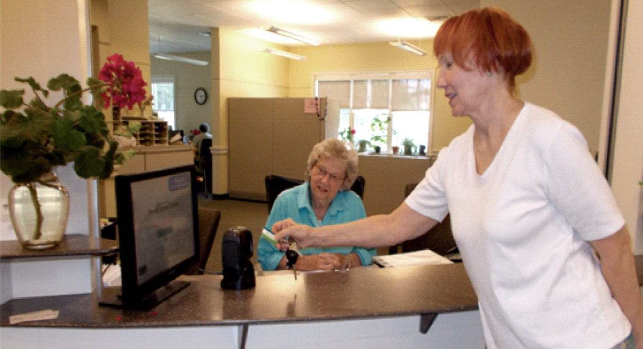
It’s easy!
JUST SWIPE YOUR KEYTAG ACROSS THE SCANNER.
- Please check in each time you visit.
- Then press the touchscreen to select the activities you want to participate in (including lunch).
The information captured will help our future funding and programming efforts.

